*Florida International University*

*School of Computing and Information Sciences*

Software Engineering Focus

Feature Document

User Story ID #216

Implementing contact us form

**Name:** Mariana Sebastian

**Team Member(s):** Nathally Perez

**Project:** Driverless Car Website 1.0

**Product Owner(s)**: Kianoosh G. Boroojeni

**Mentor(s)**: Mohsen Taheri

**Instructor**: Masoud Sadjadi

**User Story Name:** Implementing contact us form

* Description: **As a** User **I would like** to sent emails to driverless clar owners **so that** I can inquire more about their product and services and sent messages about any questions.

Acceptance Criteria

* User should be able to enter their name, email address, subject, and message in their contact us form.
* Form should be labeled with appropriate name.

**Use Case**

* Name: Implement contact us form
* Actor:Site visitor
* Preconditions: Connected to http://localhost:4000
* Description <Flow of events>:

1.User clicks contact us tab from the navbar

2.User is presented with contact us form

3 User fill out the informations in the form.

4. User clicks submit button

**Use Case Diagram:**

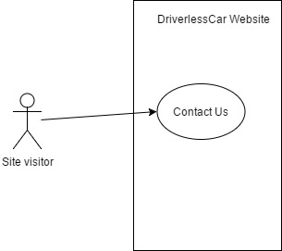

**Sequence Diagram**

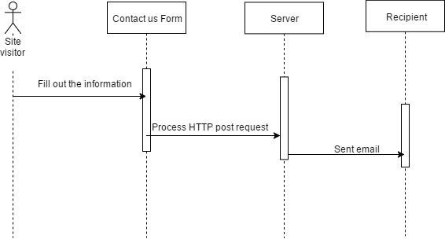

**Class Diagram**

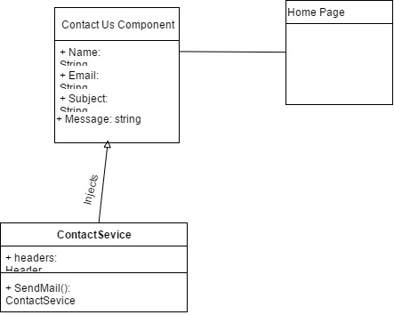

**Unit Test:**

**Test case 1(Sunny Day)**

* Test case ID:Contactus_001
* Description/Summary of Test: To test the contact form submitted successfully after the user enters the informations.
* Precondition:1. The server is running on the localhost port 4000.

2.User clicks contact us tabs from the navbar

3.User enters:

Name: Alice Walter

Email: [alicewalter@gmail.com](mailto:alicewalter@gmail.com)

Subject: New Mail

Message: New message to driverlesscar

4. User clicks submit button

* Expected Results: Message is sent to the driverlesscarinfo@gmail.com
* Actual Result: Message is sent to the driverlesscarinfo@gmail.com
* Status (Fail/Pass): PASSED

**Test case 2(Rainy Day)**

* Test case ID:Contactus_002
* Description/Summary of Test: To test the contact form won’t be submitted successfully if the user leave the name field empty
* Precondition:1. The server is running on the localhost port 4000.

2.User clicks contact us tabs from the navbar

3.User enters:

Name:

Email: [alicewalter@gmail.com](mailto:alicewalter@gmail.com)

Subject: New Mail

Message: New message to driverlesscar

4. User clicks submit button

* Expected Results: Message won’t sent to the [driverlesscarinfo@gmail.com](mailto:driverlesscarinfo@gmail.com) and name is required message will shown.
* Actual Result: Message won’t sent to the [driverlesscarinfo@gmail.com](mailto:driverlesscarinfo@gmail.com) and name is required message will shown.
* Status (Fail/Pass): FAILED

**Visual User Guide:**

